WMM1 TASK 2

**RAHUL S  
INTRODUCTION TO SYSTEMS THINKING — D372**

**WMM1 — WMM1 TASK 2: APPLIES SYSTEMS THINKING**

**PRFA — WMM1**

**TASK INSTRUCTIONS**

A. Analyze one of the case studies from the attached "Case Studies" document by doing the following:

Analyze one of the given case studies using one of the systems archetypes tools.

**Case Study 2: ICUPhone**

ICUPhone’s business follows a typical Growth and Underinvestment systems archetype, where early success grows to expansion. However, an unforeseen failure to support sustained growth causes eventual decline due to various organizational and managerial failures.

Its initial model grew well on sales at an affordable price. The demand was also decent. As the company saw this as a good sign and increased R & D for better phones and volume. However, the intended effect was the opposite when the quality deteriorated and customer service became lackluster, which in turn impacted the revenue for further R & D, and the Company started losing sales and revenue altogether.

Chosen Systems Archetype: **Growth and Underinvestment**

Completed Systems Archetype Tool

**Reinforcing Loop (Growth Phase):**

More R&D investment → Higher-quality products → Increased sales → More revenue for R&D.

**Balancing Loop (Underinvestment Phase):**

More customers → Higher support demand → Inadequate customer service → Customer dissatisfaction → Sales decline → Less revenue for R&D.

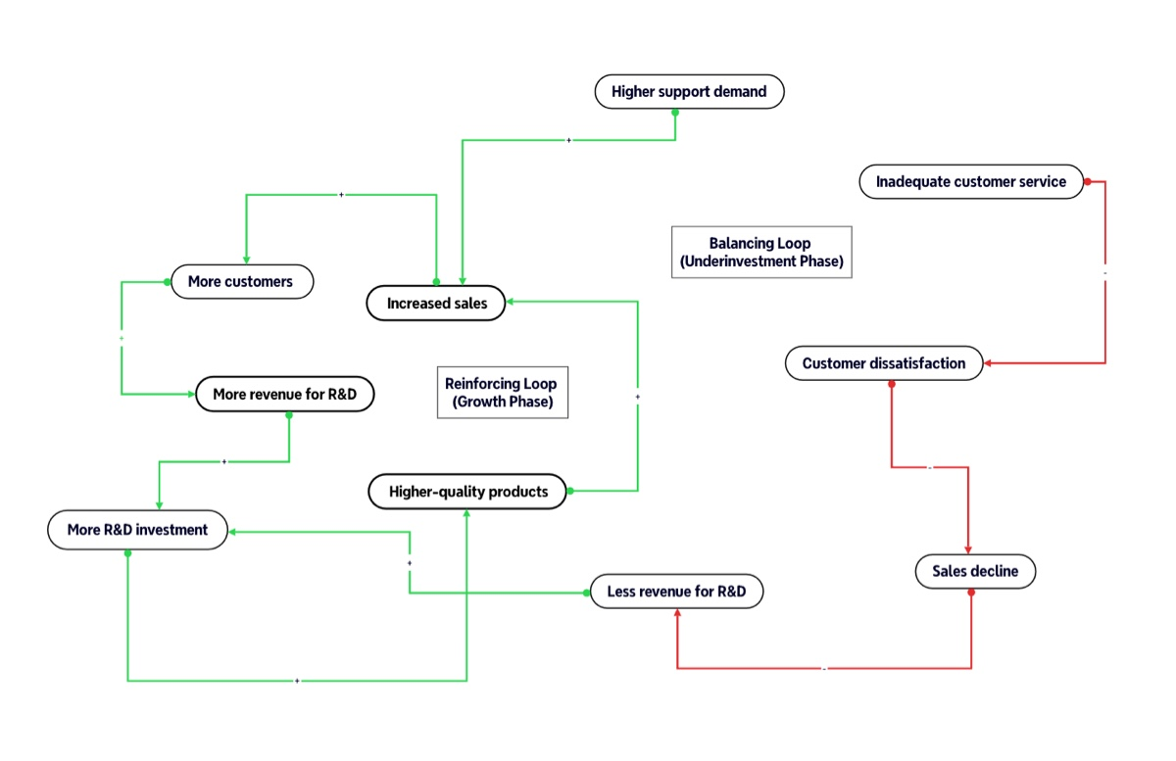

Summarize the problems in the case study as understood through its relationships, properties, and subsystems as a result of the changes that occur.

ICUPhone started with a decent reputation for high-quality video phones. Investment in R&D led to increased sales and further strengthened their success. As sales grew, more customers required customer support. However, ICUPhone did not expand support services with the R & D but neglected it thoroughly.

The complete lack of sufficient customer support made customers unhappy, thus leading to increasing service issues and pressure on the after-sales service department.  
Due to poor service revelations, customer satisfaction went downhill, thus leading to lower sales altogether.

The drop in revenue streams meant that ICUPhone had to **cut R&D funding**, further limiting innovation and pushing the company far behind competitors.

Since ICUPhone failed to provide quality customer support, it started a vicious cycle of declining sales, revenue, and a bad reputation, leading to a continuous decline of the company.

**SUMMARY**

ICUPhone’s failure followed the **Growth and Underinvestment** archetype, wherein they expanded rapidly without strengthening **support infrastructure**, ultimately leading to **business decline**. The company should have invested in customer service alongside R&D to break the cycle and maintain sustainable growth.